Task1

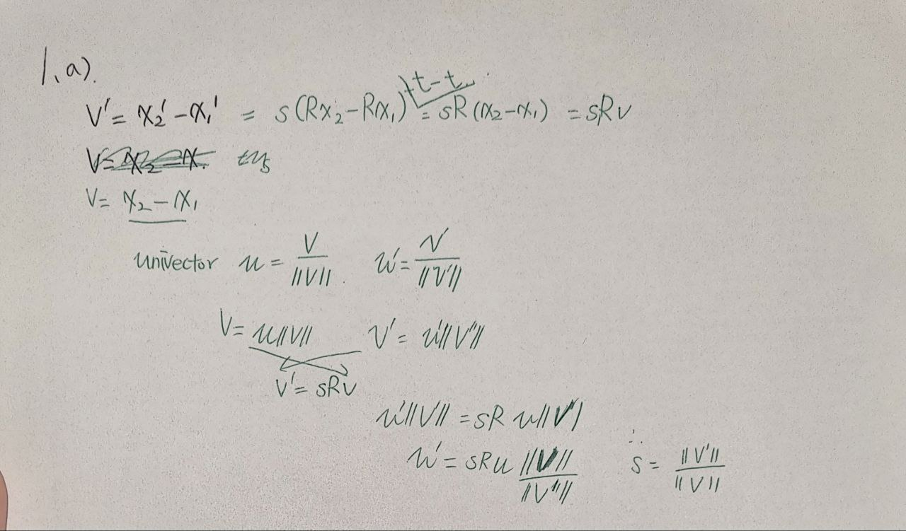

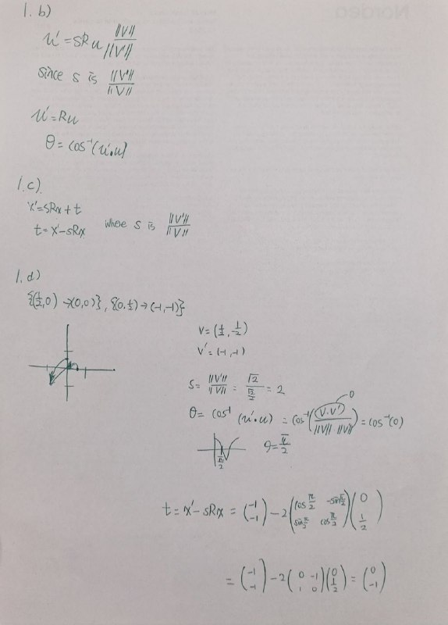

Task2

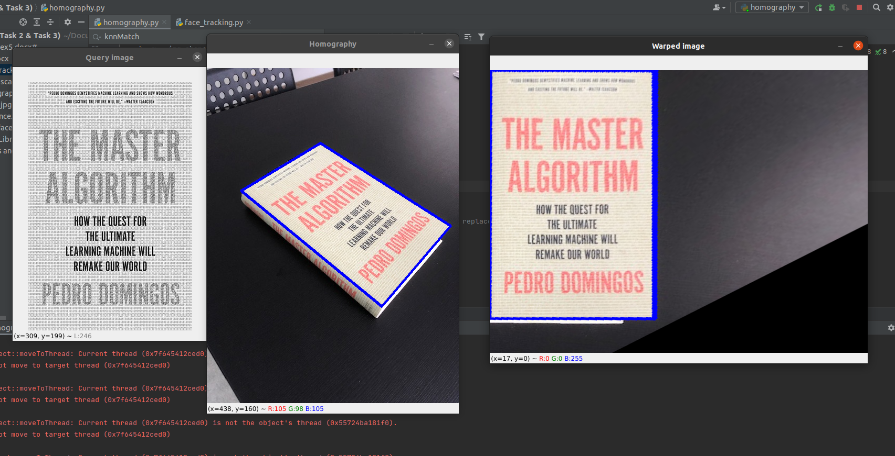

Task3

a

Detect faces from the frame using face cascade detection.

If there is a face, extract a rectangle surrounding the face from the frame.

If there is a face, get trackable points from the face rectangle.

Calculate the optical flow of those trackable points from the previous frame.

Draw the markers to the location of the new calculated points from their optical flow.

Repeat all above until the user press q.

b

Some points can be outside the face. This can be avoided by cropping

the face rectangle. And find the trackable point within the cropped face rectangle.